Coffee Chain Management System

Supplementary Specification

Version 1.0

Revision History

|  |  |  |  |
| --- | --- | --- | --- |
| **Date** | **Version** | **Description** | **Author** |
| 20/MAR/2019 | 1.0 | Initial Requirements Statement | Floriana Cenan |
|  |  |  |  |
|  |  |  |  |
|  |  |  |  |

Table of Contents

1. Introduction 4

2. Non-functional Requirements 4

2.1 Availability 4

2.2 Performance 4

2.3 Security 4

2.4 Testability 4

2.5 Usability 5

3. Design Constraints 5

Supplementary Specification

# Introduction

The Supplementary Specification captures the system requirements that are not readily captured in the use cases of the use-case model. Such requirements include:

* Legal and regulatory requirements, including application standards.
* Quality attributes of the system to be built, including usability, reliability, performance, and supportability requirements.
* Other requirements such as operating systems and environments, compatibility requirements, and design constraints.

# Non-functional Requirements

## Availability

The system is not expected to be used in urgent scenarios so we can afford an SLA[1] of 99.5%. This translates into a yearly downtime of roughly 1 day and 19 hours, or a monthly downtime of 3 hours and 39 minutes. This time can be used to perform software updates, data compression and garbage collection.

## Performance

Performance is not a key factor for our system. For this reason, we can allow a response time of up to 30 seconds for request submissions in the worst case scenario. The average response time, depending on the load of the system, should be 1 second.

## Security

The system will be secured using https encrypted connections. Also, we will demand user authentication and will not keep passwords in plain text. Other user data will not be encrypted as we do not find it as being sensible information.

## Testability

The business logic of the application must be tested independently from the user interface. We will employ V-Model testing as illustrated in **Error! Reference source not found.**. We aim to have over 90% test coverage, through unit and integration tests. With respect to manual testing, the system will log all information that is not displayed in the user interface, so that the system is fully observable and testable.

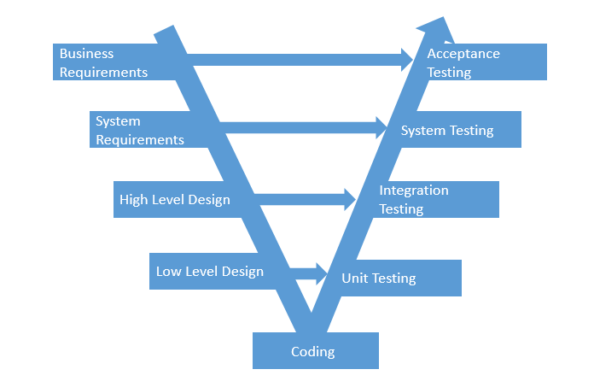

## Usability

The user should be able to reach any desired goal in under 30 mouse clicks. Also, since system administator works under stress, the system state will be displayed to him at all times and any terminal operation will prompt a confirmation dialog that describes the consequences of the action.

# Design Constraints

The system is constrained to use Java 8 as implementation language. The software development process will be the Rational Unified Process (RUP), tailored to fit the team and the project. The conceptual architecture of the system will be a client server as illustrated in Figure 1 Conceptual Architecture. The required development tools are either Eclipse IDE or IntelliJ IDEA. In terms of libraries we will use: JavaFX, Hibernate, JDBC and GSON.

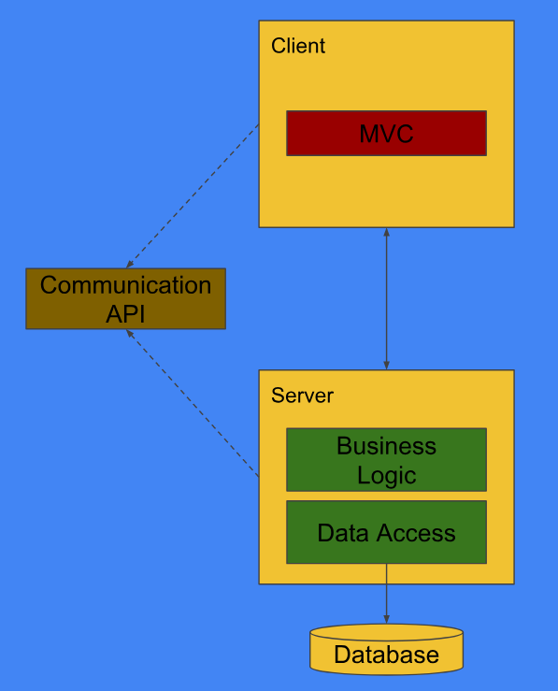

Figure 1 Conceptual Architecture

1. SLA = Service Level Agreement = Availability